SAMPLE ACTIVITIES FROM
CATCH My Breath Lessons

INGREDIENTS IN E-CIGARETTS –
Read out information on an ingredient. (Sheet printed with information)
- Determine which ingredient I am reading about.
- Then, perform the action assigned to each ingredient in place until I call out the next ingredient.
- JUUL: Jumping jacks
- Nicotine: High knees
- Propylene Glycol: Hop in place
- Some of 7,000+ flavoring ingredients: Squats
- Addiction: March in place
- Aerosol: Standing oblique crunches
- Toxic Chemical: Calf raises
- Formaldehyde: Front lunges

Activity: Why Do It? (11 min.) -
- Distribute an index card or paper square to each student.
- Ask each student to use the index card to write on one side what they believe to be the top reason why young people may experiment with e-cigarettes.
- Explain: Once each student has written a reason for experimenting with e-cigarettes on a card, everyone in the group will pass the cards around (until each student has a card that isn’t theirs). On the other side of the card, each student will write a positive alternate activity to smoking an e-cigarette based on the reason for use listed on the front of the card.
- Ask each Peer Group Facilitator to report 2-3 of the reasons for use that their group listed along with 2-3 positive alternatives.
RUFUSAL SKILLS –
Skill cues: I SAY NO
- Distribute an index card or paper square to each student. Instruct students to think of unique ways to say "no" if offered an e-cigarette. Remind students to be creative, not hurtful, and to avoid putting others down.
- Share answers students came up with and review the Smart Exit Strategies examples provided in the presentation.
- Ask the entire class to form a circle.
- Explain: you will toss a ball to one another. When a student receives the ball, they must give a refusal/exit strategy. You must come up with a unique refusal on the spot to remain standing. Last students standing wins!
Consequences of Using E-cigarette -
- Ask students to assemble into their groups.
- Distribute an index card or square of paper to each student.
- Explain: You will be brainstorming consequences of using E-cigarette in your groups.
  - One half of the group will list health consequences of using e-cigarettes.
  - The other half of the group will list social consequences of using e-cigarette e.g. consequences related to social situation, family, personal identity and goals.
  - You will switch cards/papers with the opposite group to fill in any gaps for possible responses.
- Remind students that there are no wrong answers
- Ask each peer group facilitator (or another student in each group) to report one health consequence and one social consequence.
- Record their responses on a whiteboard.
- Reveal the example health and social consequences on the respective slides.
CONSEQUENCES, Part II
- Explain: E-cigarettes are not harmless and have lots of health and social consequences associated with using them.
- Instruct students to find a partner and get toe-to-toe with them
- One partner will exchange a health consequence and the other will exchange a social consequence
- The students will then do the activity listed on the board associated with the consequence
- One you have completed the exchange of consequences and physical activity, you will march in place until I say SWITCH.
- When I say SWITCH, you will run and get toe-to-toe with a new partner and exchange health and social consequences again.
- We will repeat this activity five times.

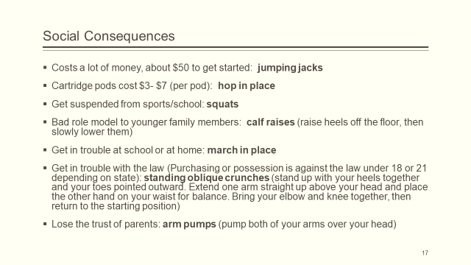

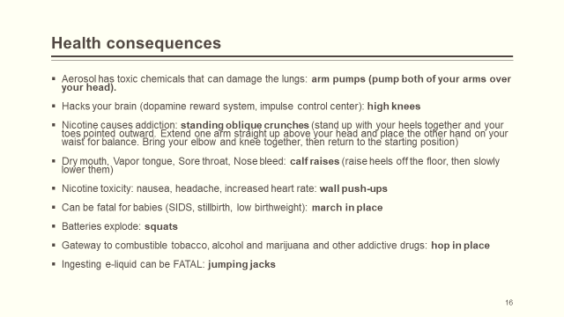

True/False -
- After each statement:
  - If you think the statement is “true”, march in place.
  - If you think the statement is “false” do jumping jacks in place (Emphasize that guessing is okay) (I use punch it out)
- Read each statement out loud.
- Reveal the correct answer once all students are performing an activity.
  - The “smoke” that comes out of E-cigarettes is harmless water vapor.
    - False: It is an aerosol, or fine spray, of toxins and nicotine.
  - Almost all e-cigarettes contain nicotine, with some brands containing more nicotine than a conventional cigarette.
    - True: nearly all e-cigarettes contain nicotine, even the flavored ones.
  - Most teens smoke e-cigarettes.
    - False: Nearly 80% of high school students and more than 95% of middle school students do NOT smoke e-cigarettes.
  - JUUL is not an e-cigarette.
    - False: JUUL is the most popular brand of e-cigarette in the United States.
  - E-cigarettes contain fewer toxic chemicals than conventional cigarettes.
    - True: E-cigarettes do have fewer toxic chemicals than conventional cigarettes, but e-cigarettes still contain nicotine and other toxins.
  - Flavored cigarettes don’t contain nicotine.
    - False: 95% of flavored e-liquid contains nicotine.
  - Nicotine is nearly as addictive as coffee.
    - False: nicotine is much more addictive than coffee.
  - E-liquid is highly toxic and can even be fatal to anyone who swallows it.
    - True: across the U.S. there are hundreds of calls placed to poison control centers each month due to people drinking e-liquid.
  - Teenagers become addicted to nicotine easier than adults.
    - True: Developing brains are more sensitive to the addictive nature of nicotine.
  - Young people who use e-cigarettes are less likely to use conventional cigarettes in the future.
    - False: Young people who use e-cigarettes are FOUR TIMES as likely to start using conventional cigarettes within 18 months as those who do not use e-cigarettes at all.
  - E-cigarettes contain formaldehyde, which is used to preserve dead bodies.
    - True: Formaldehyde is just one of the toxic chemicals produced by e-cigarettes.
  - Indirect Advertising hides the fact that it is an ad.
    - True: Often it is difficult to know that a company is advertising if you see a celebrity or athlete using their product.
  - E-cigarette batteries are known to occasionally explode in people’s pockets or mouths.
    - True: The shape and construction of e-cigarettes makes them more likely than other products with lithiumion batteries to behave like “flaming rockets” when a battery fails.
  - When polled, most teens approved of e-cigarette use.
    - False: The vast majority of students polled did not think e-cigarette use was acceptable or cool.
  - E-cigarettes don’t affect your athletic performance.
    - False: E-cigarette contain toxins that are known to damage lungs, plus nicotine weakens heart health.

